January 12, 2021

# MUSTAHIQ,

## Hello!

I built the app using the latest version of Android studio with Android X libraries. On build gradle file one can see all the libraries which i have used in the app, one can change the sdk version for different android platforms from this area. Gradle file is one of the critical file in android app, developer can bring numerous programmatically stuff over here

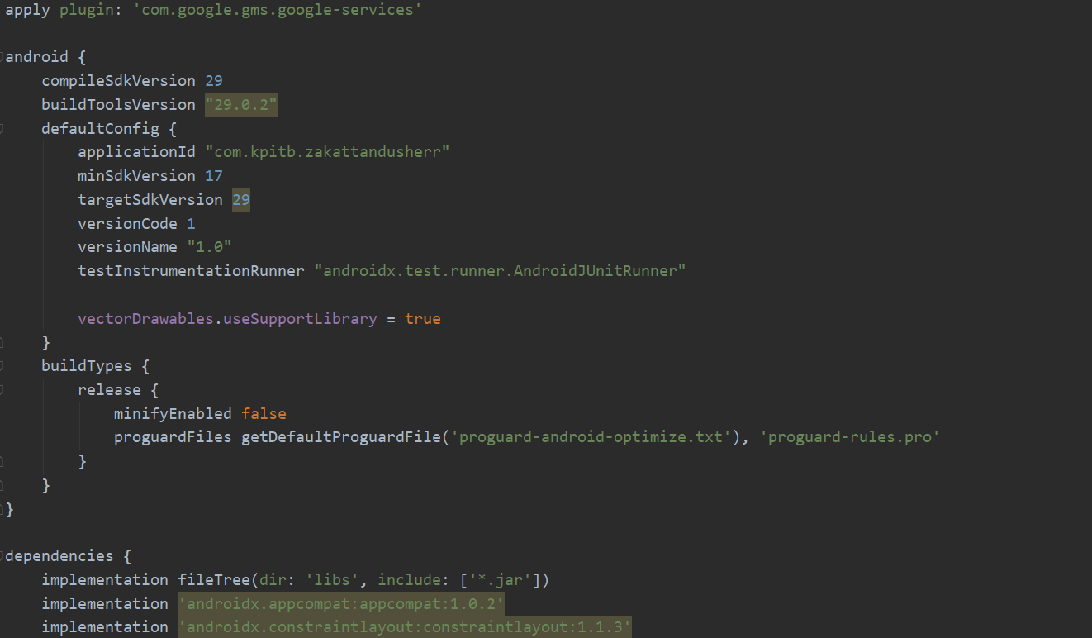

It is recommended that first one should go and read out the manifest file as over there one can get an idea about all the activities, user permissions and their theme information.

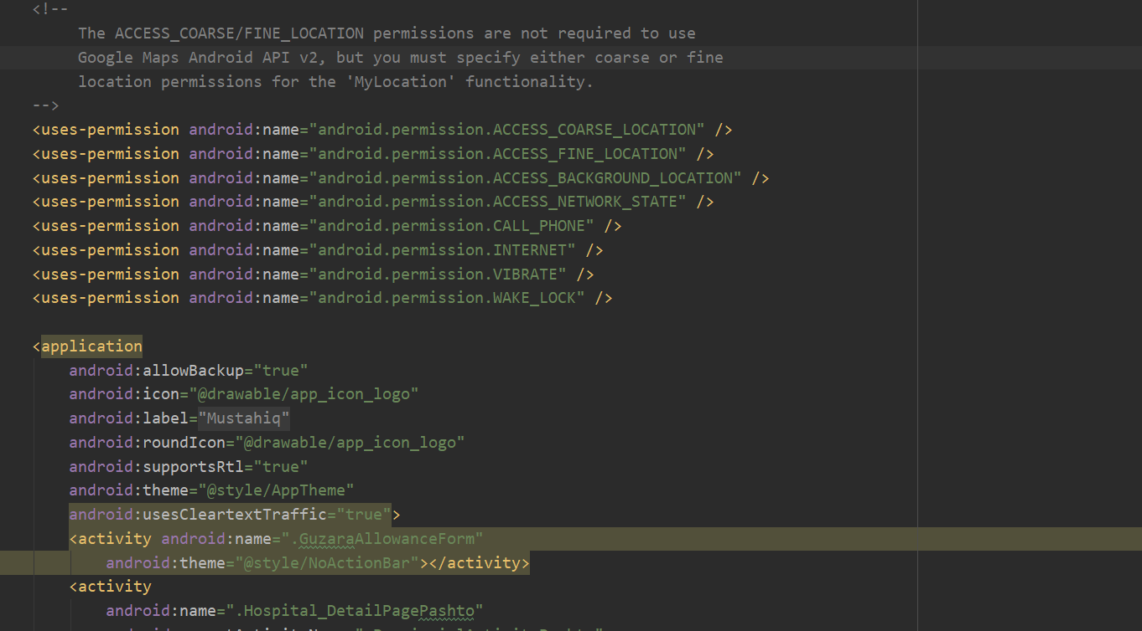

Here we have two different types of data and resources. All the zakat schemes and their explanation info are all static and one can find it in XML screens they can edit and bring changes in that text from there.

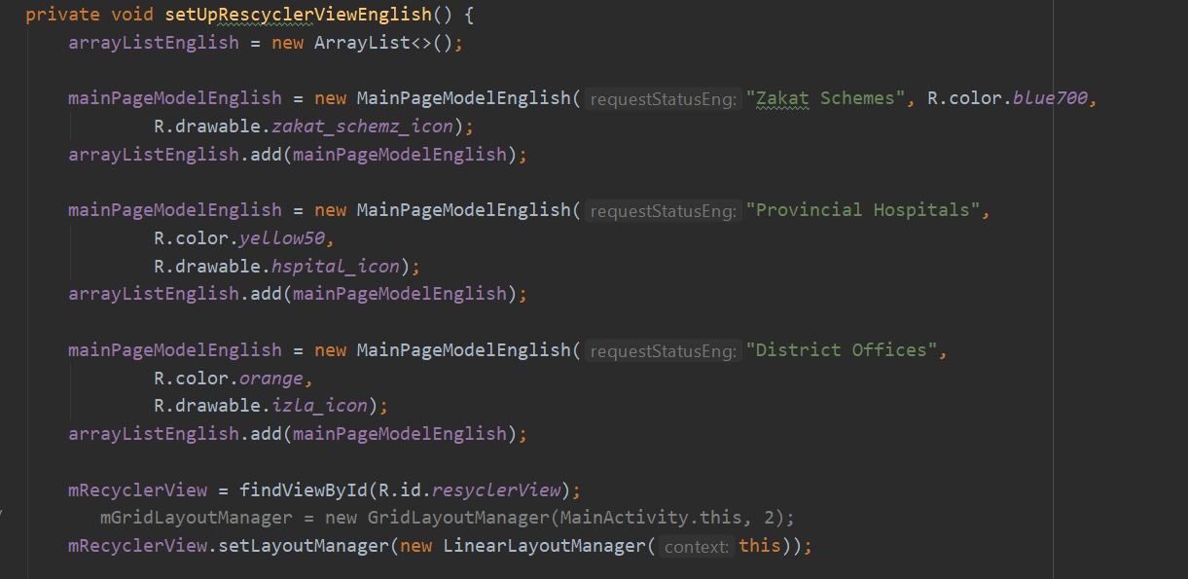

Here is the XML screen where one can add and edit static data for different zakat schemes:

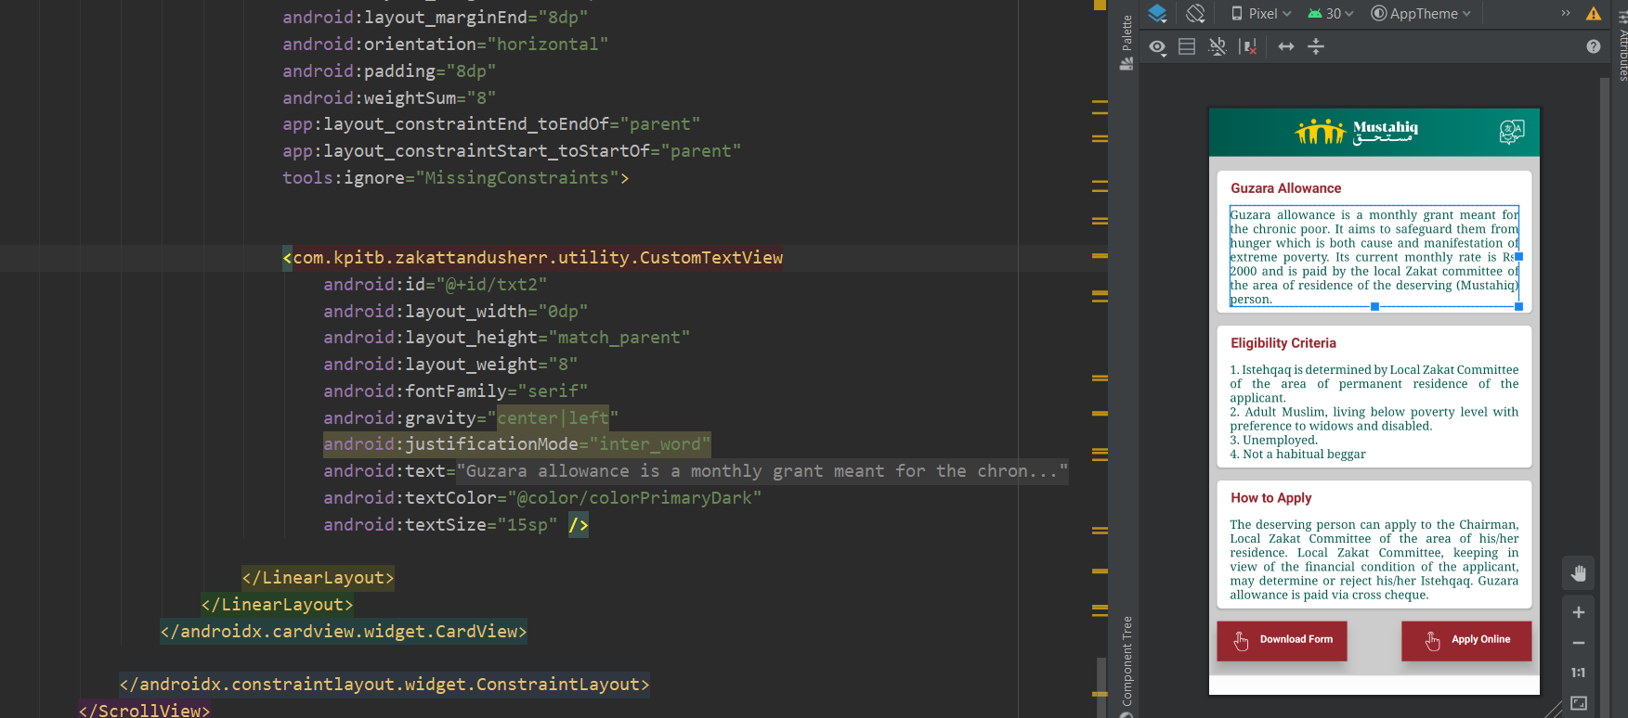

Other data is dynamic like hospital information and district information, this dynamic data comes to the app through web services online, for this I have used Volley library through I fetched data dynamically from web services apis. So in order to bring changes in dynamic data one has to do changes in the web dashboard, once the user submit changes over there, the app will get the changed data automatically through the volley library.

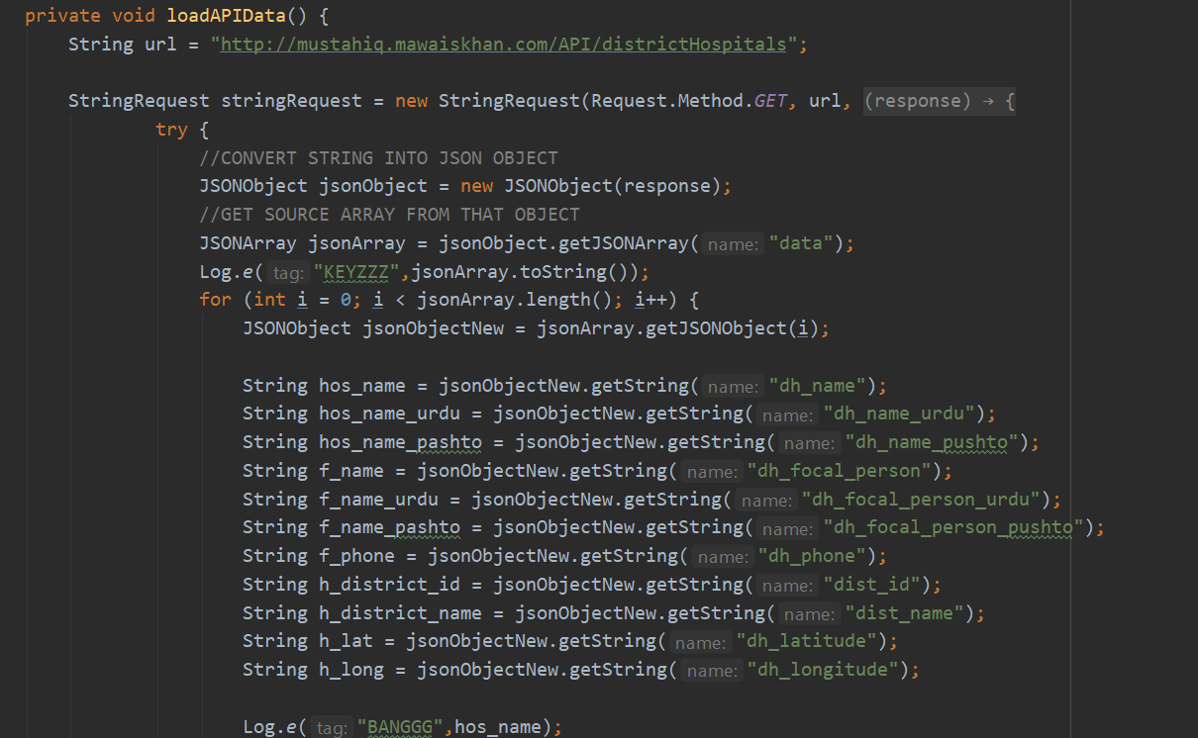

The zakat scheme forms can be downloaded from the static URL provided in the code.

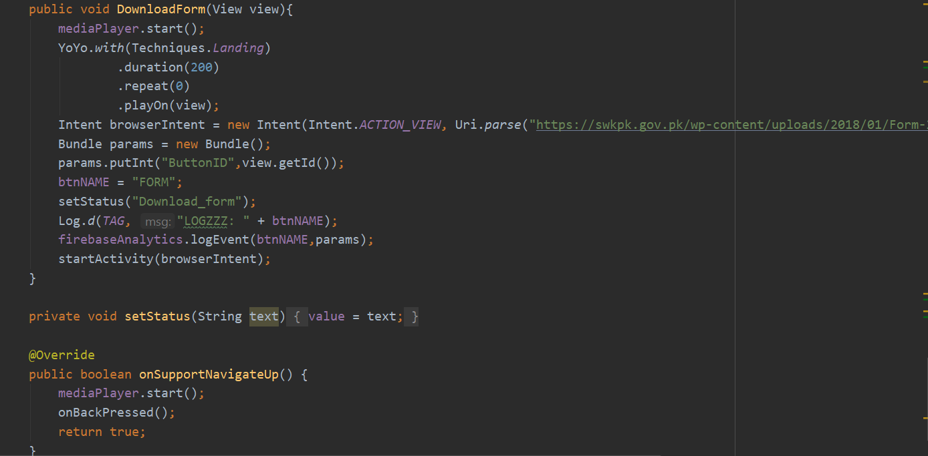

The app has google maps for that I have used Google map api, the api is unique value one can find that value on maps activity in XML screen.

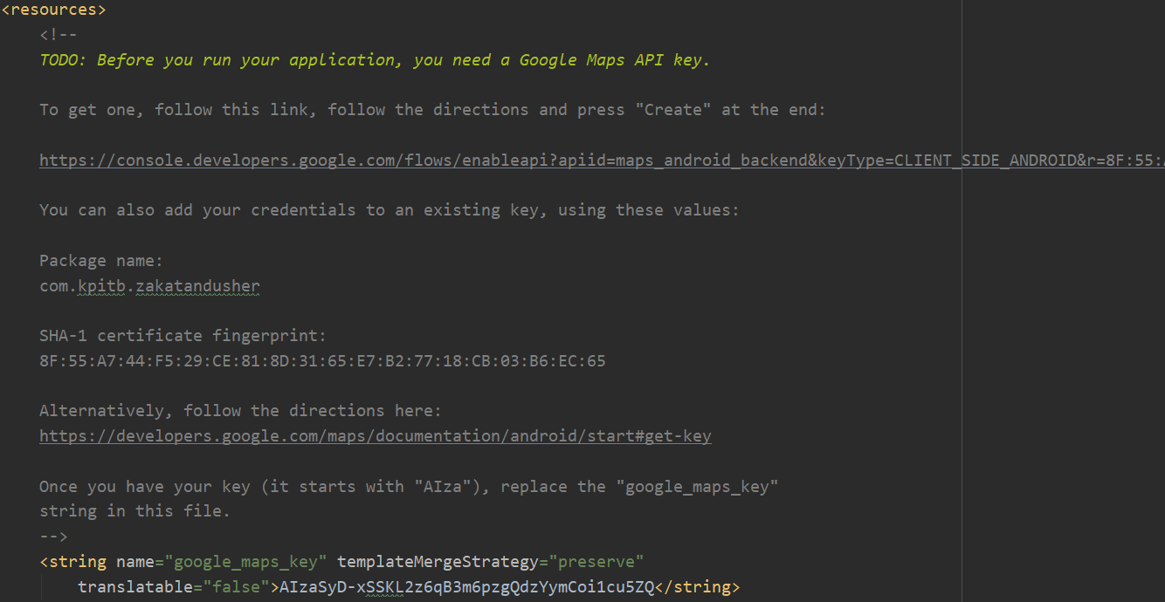

The app also has a tutorial video at the beginning which is online on YouTube, for that I have used YouTube Player and also its unique value in order to fetch the video on my app.

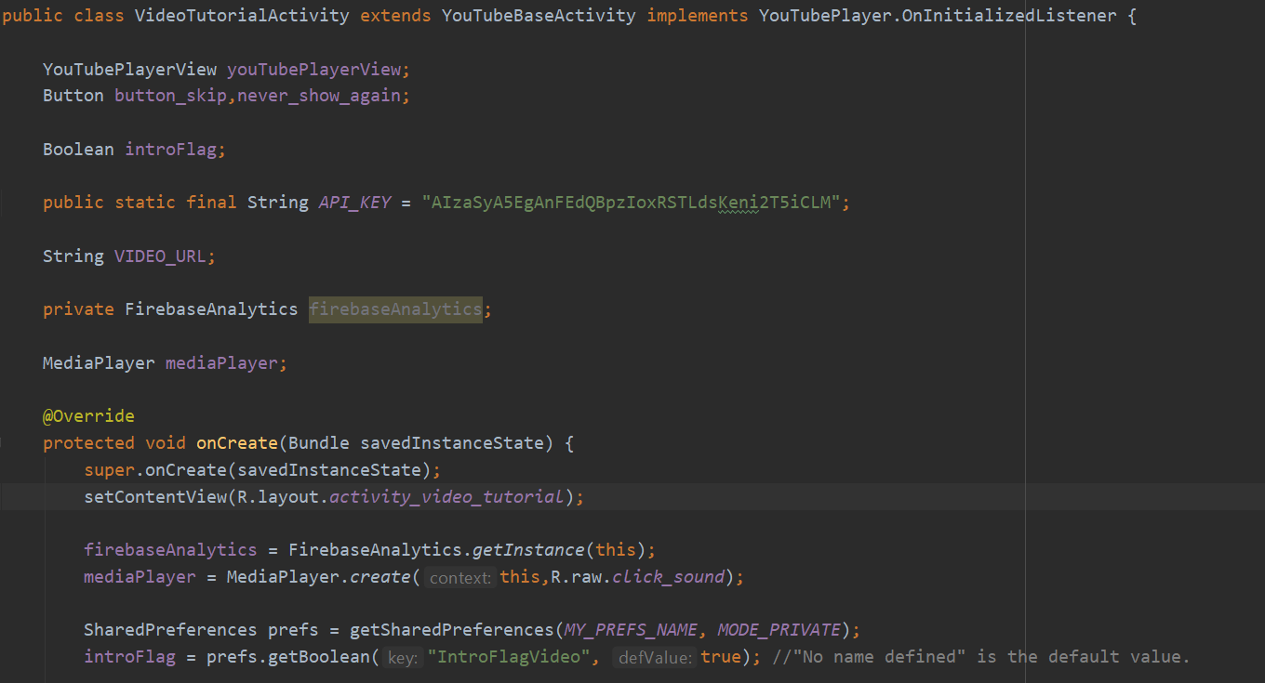

Throughout the whole coding I have used several comments in different activities where one can get a clear idea what’s going on.

Yours obediently,

Tauseef Ahmad